Waffles 1
http://allrecipes.com/recipe/22180/waffles-i/
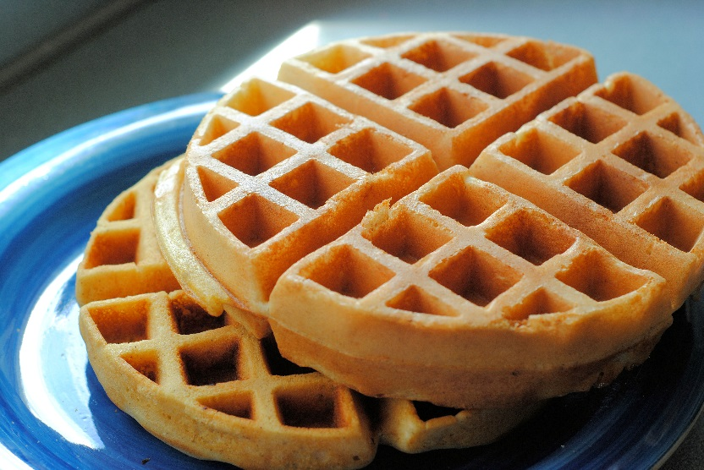
2 eggs
2 cups all-purpose flour
1 ¾ cups milk
½ cup vegetable oil
1 tablespoon white sugar
4 teaspoons baking powder
¼ teaspoon salt
½ teaspoon vanilla extract

- Preheat waffle iron. Beat eggs in a large bowl with hand mixer until fluffy. Beat in flour, milk, vegetable oil, sugar, baking powder, salt, and vanilla, just until smooth.

- Spray preheated waffle iron with non-stick cooking spray (if needed). Pour mix on to hot waffle iron. Cook until golden brown. Serve hot.
- All done! Enjoy!

